Enquiry for Suncombe GMPWasher
In order to assist us in evaluation of your requirements, please complete as much as possible of the following form. We would also appreciate if you could send drawings of your requirement to: E-mail: salesdept@suncombe.com.

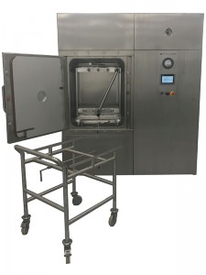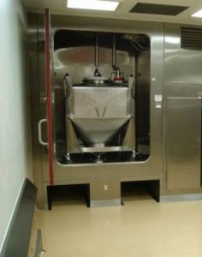
PureKleen ™ Parts Washer IBCWashBooth ™

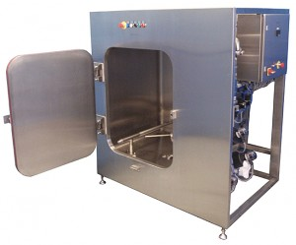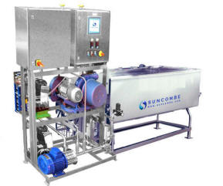

Steriwasher ™ ImmersionWasher ™

*Required

